1. What are three conclusions we can make about Kickstarter campaigns given the provided data?

(a) From category pivot table/chart, the "theater" has the most total states, "successful" state, "failed" state, and "live" state

(b) From sub-category pivot table/chart, the "play" in "theater" has the most total states, "successful" state, and "failed" state

(c) Compared to other months, May has more "successful" state

2. What are some of the limitations of this dataset?

(a) There are some abnormal data, which might be misleading. For example, the id of 2734, 2243, 1253, and 1012 has the percent of fund as 2260300%, 930250%, 303833.2%, and 21535.02%, while normal percentage are around

(b) The data may not be comprehensive. For example, although "theater" was the most popular category - had the most counts of states, no "failed" state was reported in October from year 2009 to 2017, and this is abnormal

3. What are some other possible tables/graphs that we could create?

(a) the pie graph "country VS sum of pledged"-shows US is the country which has the highest pledged amount

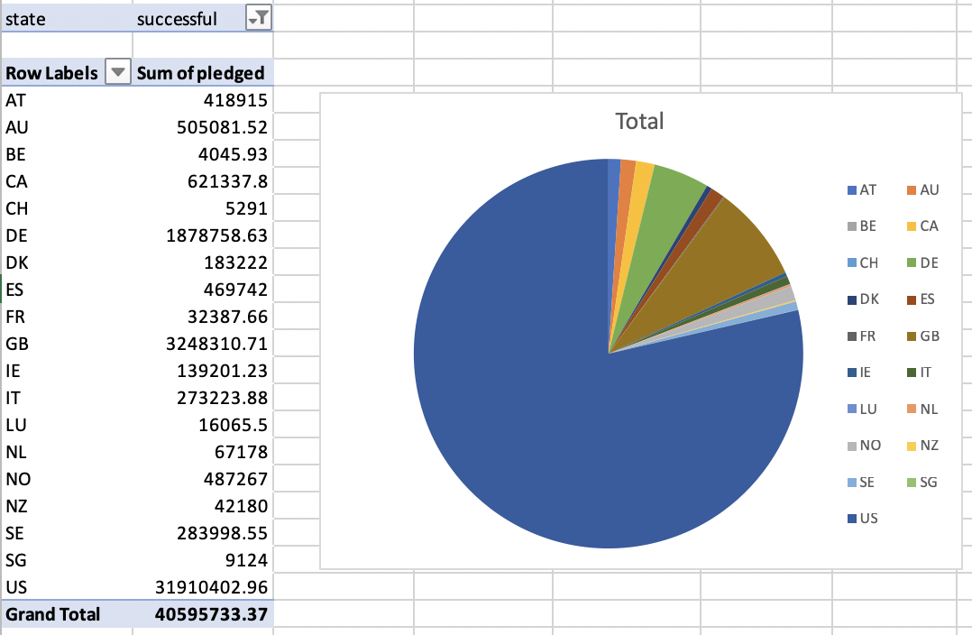

(b) the pie graph "category VS sum of pledged"-shows technology is the category which has the highest pledged amount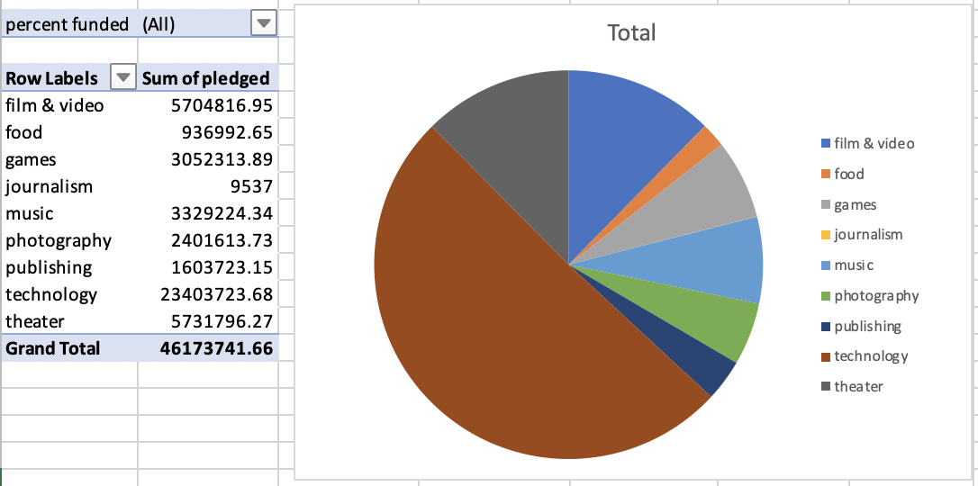

(c) the pie graph "country VS projects"-shows US is the country which has the most states

